Department: Computer Science & Engineering

Lecturer: Nguyễn Thị Thuý Loan

**REPORT OF FINAL PROJECT**

**SUBJECT : PRINCIPLE OF DATABASE MANAGEMENT**



**TOPIC: TASK MANAGEMENT SYSTEM**

GROUP : 6

Member : Trần Đình Khôi Nguyên - ITITIU19166

Huỳnh Đức Phát - ITITIU19177

Nguyễn Việt Hoàng Nam - ITITIU19162

Nguyễn Quốc Hồng Kỳ - ITITIU19151

| **Attribution** | | | | |
| --- | --- | --- | --- | --- |
| Name | Trần Đình Khôi Nguyên | Huỳnh Đức Phát | Nguyễn Việt Hoàng Nam | Nguyễn Quốc Hồng Kỳ |
| % attributed | 25% | 25% | 35% | 15% |
| Tasks | ERD, code Java,  MySQL query,  Report. | RD, code Java,  MySQL query | ERD to RD, UI/UX, code Java | Code Java, ppt slide, MySQL query. |

**Technology**

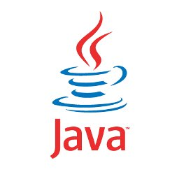

Contents :

**CHAPTER 1 : Introduction & Goal……………………………………**

**CHAPTER 2 : environment settings…………………………………...**

* MySQL
* NetBean

**CHAPTER 3** **: Design ERD & RD…………………………………….**

**CHAPTER 4 : Implement Java code & SQL query…………………..**

**CHAPTER 5 : Hardware & Software requirement………………….**

* Hardware
* Software

**CHAPTER 6 : Application Demo………………………………………**

**CHAPTER 7 : Conclusion………………………………………………**

* Advantage
* Disadvantage
* Lessons Learned

**—------------------------------------------------------------------**

## CHAPTER 1 : INTRODUCTION & GOAL

* **Introduction :**

In today's modern life, each of us is always busy with many different jobs. Multitasking is a well-known phrase in today's 4.0 era. With the purpose and desire to help people manage their work in a better way, our team has come to the decision to choose a topic: “ TASK MANAGEMENT SYSTEM”

* **Our Goal:**

Our team wants to bring everyone an easy and friendly application to manage their main tasks. This system is very simple, with just a few buttons to add, delete, view updates, everyone can easily manage their jobs. Besides, this application can develop not only on desktop platforms but also on other platforms such as mobile phones, . . .

* **Requirement:**
* *Functional:*

The admins supervises the tasks and tasks category.

The clients interact with the tasks by requesting to them.

The project managers handle all the tasks.

The employee just maneuver around the task update.

* *Non-Functional:*

Philosophy of writing code for maintenance:

1. Write short units of code: Shorter units are easier to analyze, test, and reuse.
2. Write simple units of code: Units with fewer decision points are easier to analyze and test.
3. Keep unit interfaces small: Units with fewer parameters are easier to test and reuse.
4. Separate concerns in modules: Modules that are loosely coupled are easier to modify and lead to a more modular system.
5. Keep the codebase small: A large system is difficult to maintain, because more code needs to be analyzed, changed, and tested. Also, maintenance productivity per line of code is lower in a large system than in a small system.
6. Write clean code: Having irrelevant artifacts such as TODOs and trash code in the codebase makes it more difficult for other team members to become productive. Therefore, it makes maintenance less efficient.



**—------------------------------------------------------------------**

## CHAPTER 2: ENVIRONMENT SETTINGS

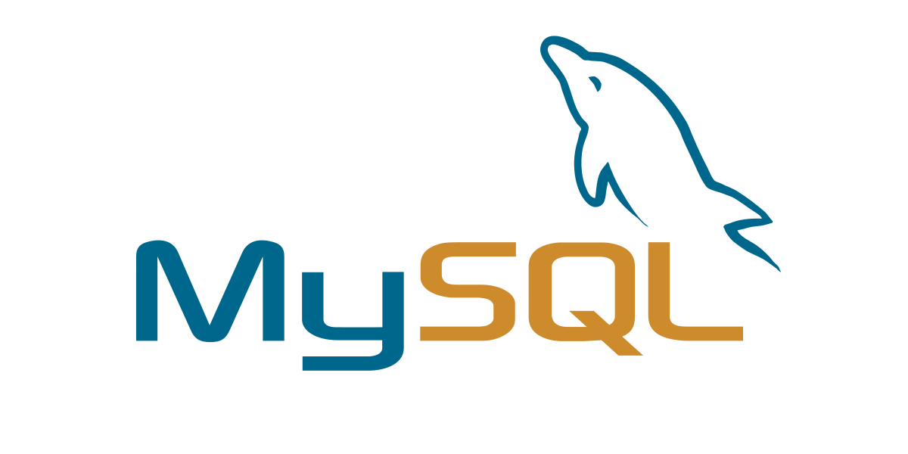

* MySQL is one of the most popular relational database management software that is widely used in today's industry. It provides multi-user access support with various storage engines. It is backed by Oracle Company. In this section, we are going to learn how we can download and install MySQL for beginners.

Prerequisites

The following requirements should be available in your system to work with MySQL:

* MySQL Setup Software
* Microsoft .NET Framework 4.5.2
* Microsoft Visual C++ Redistributable for Visual Studio 2019
* RAM 4 GB (6 GB recommended)
* Download MySQL
* Follow these steps:

**DOWNLOAD MYSQL :**

**Step 1**: Go to the official website of MySQL and download the community server edition software. Here, you will see the option to choose the Operating System, such as Windows.

**Step 2**: Next, there are two options available to download the setup. Choose the version number for the MySQL community server, which you want. If you have good internet connectivity, then choose the mysql-installer-web-community. Otherwise, choose the other one.

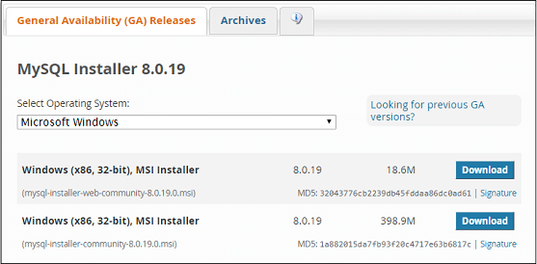

**INSTALLING MYSQL:**

**Step 1**: After downloading the setup, unzip it anywhere and double click the MSI installer .exe file. It will give the following screen:

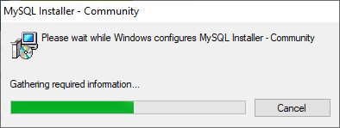

**Step 2**: In the next wizard, choose the Setup Type. There are several types available, and you need to choose the appropriate option to install MySQL product and features. Here, we are going to select the Full option and click on the Next button.

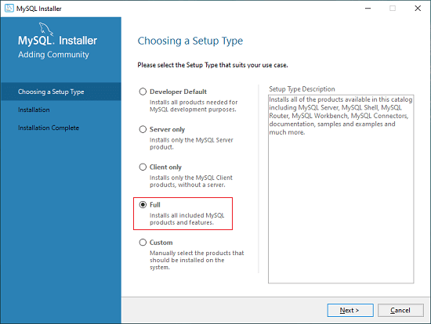

This option will install the following things: MySQL Server, MySQL Shell, MySQL Router, MySQL Workbench, MySQL Connectors, documentation, samples and examples, and many more.

**Step 3**: Once we click on the Next button, it may give information about some features that may fail to install on your system due to a lack of requirements. We can resolve them by clicking on the Execute button that will install all requirements automatically or can skip them. Now, click on the Next button.

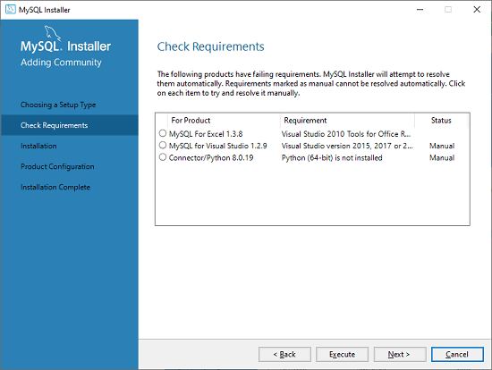

**Step 4**: In the next wizard, we will see a dialog box that asks for our confirmation of a few products not getting installed. Here, we have to click on the Yes button.

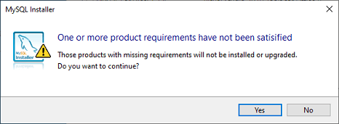

After clicking on the Yes button, we will see the list of the products which are going to be installed. So, if we need all products, click on the Execute button.

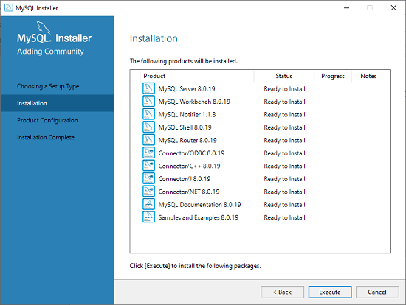

**Step 5**: Once we click on the Execute button, it will download and install all the products. After completing the installation, click on the Next button.

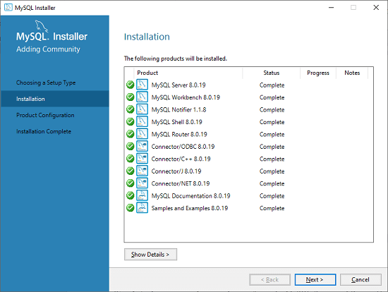

**Step 6**: In the next wizard, we need to configure the MySQL Server and Router. Here, I am not going to configure the Router because there is no need to use it with MySQL. We are going to show you how to configure the server only. Now, click on the Next button.

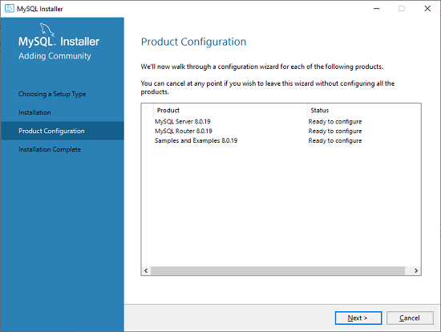

**Step 7**: As soon as you will click on the Next button, you can see the screen below. Here, we have to configure the MySQL Server. Now, choose the Standalone MySQL Server/Classic MySQL Replication option and click on Next. Here, you can also choose the InnoDB Cluster based on your needs.

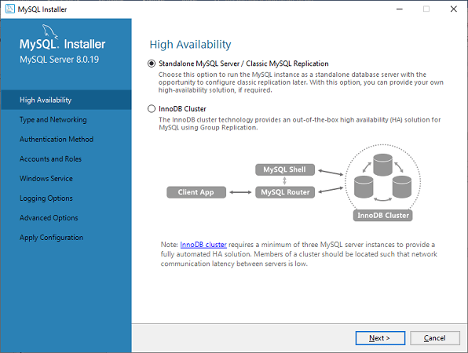

**Step 8**: In the next screen, the system will ask you to choose the Config Type and other connectivity options. Here, we are going to select the Config Type as 'Development Machine' and Connectivity as TCP/IP, and Port Number is 3306, then click on Next.

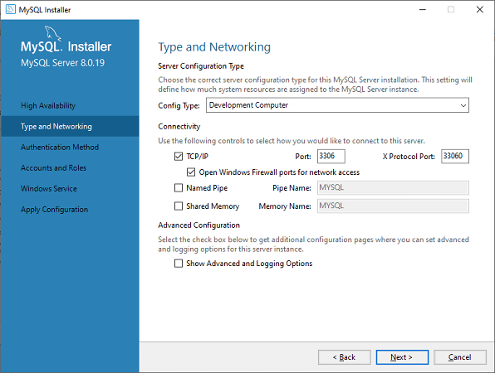

**Step 9**: Now, select the Authentication Method and click on Next. Here, I am going to select the first option.

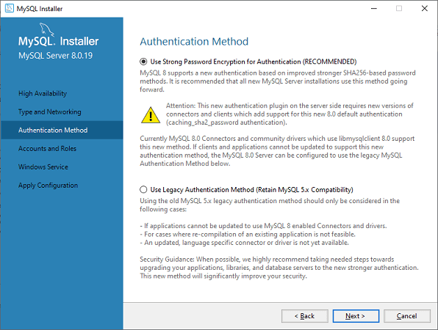

**Step 10**: The next screen will ask you to mention the MySQL Root Password. After filling the password details, click on the Next button.

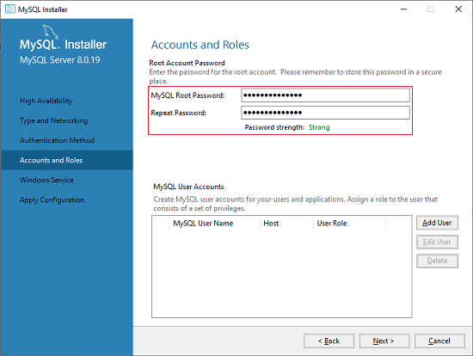

**Step 11**: The next screen will ask you to configure the Windows Service to start the server. Keep the default setup and click on the Next button.

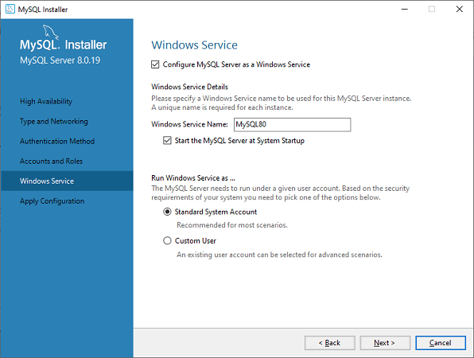

**Step 12**: In the next wizard, the system will ask you to apply the Server Configuration. If you agree with this configuration, click on the Execute button.

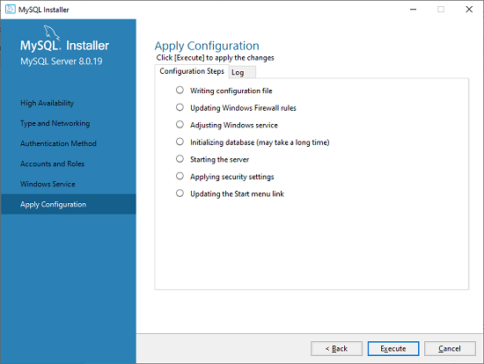

**Step 13**: Once the configuration has completed, you will get the screen below. Now, click on the Finish button to continue.

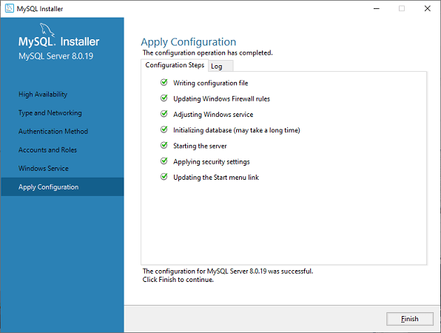

**Step 14**: In the next screen, you can see that the Product Configuration is completed. Keep the default setting and click on the Next-> Finish button to complete the MySQL package installation.

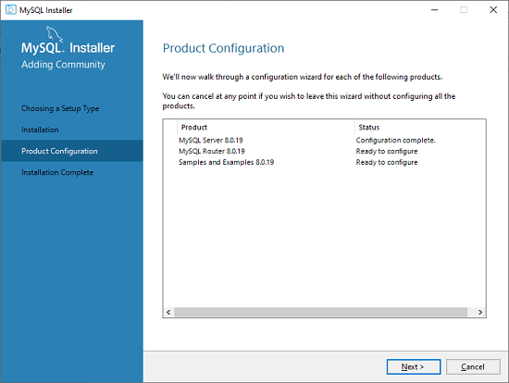

**Step 15**: In the next wizard, we can choose to configure the Router. So click on Next->Finish and then click the Next button.

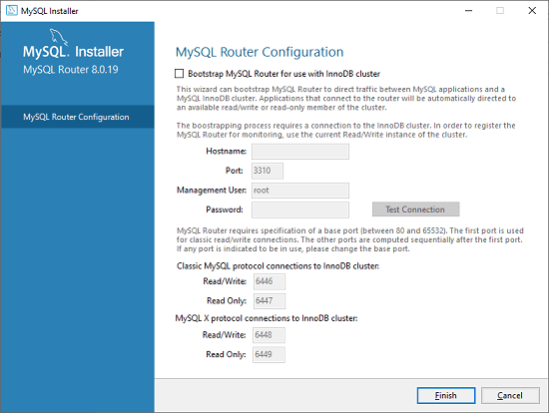

**Step 16**: In the next wizard, we will see the Connect to Server option. Here, we have to mention the root password, which we had set in the previous steps.

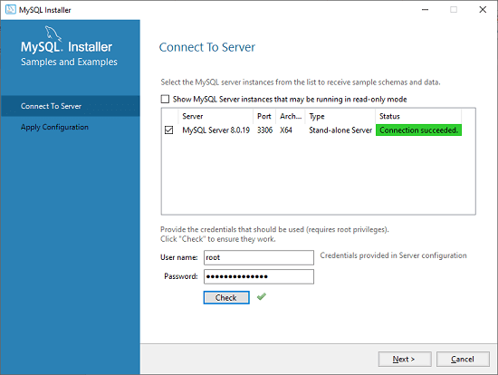

In this screen, it is also required to check about the connection is successful or not by clicking on the Check button. If the connection is successful, click on the Execute button. Now, the configuration is complete, click on Next.

**Step 17**: In the next wizard, select the applied configurations and click on the Execute button.

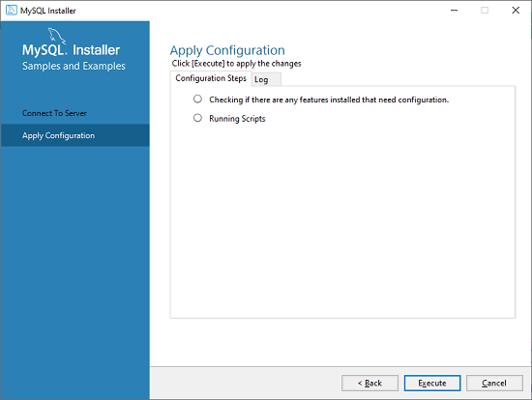

**Step 18**: After completing the above step, we will get the following screen. Here, click on the Finish button.

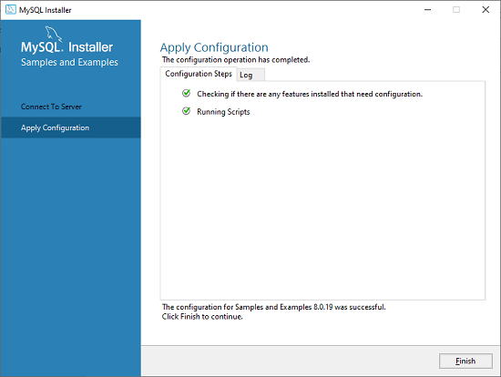

**Step 19**: Now, the MySQL installation is complete. Click on the Finish button.

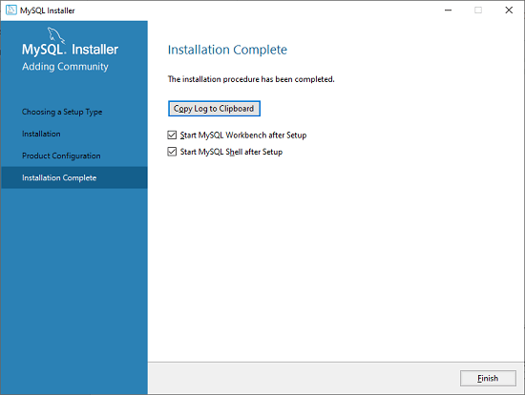

Verify MySQL installation

- Once MySQL has been successfully installed, the base tables have been initialized, and the server has been started, you can verify its working via some simple tests.

**INSTALLING NETBEAN:**

#### **\* How to Install NetBeans on Windows**

##### **Step 0: Install JDK**

To use NetBeans for Java programming, you need to first install Java Development Kit (JDK). See "[JDK - How to Install](https://www3.ntu.edu.sg/home/ehchua/programming/howto/JDK_HowTo.html)".

##### **Step 1: Download**

Download "NetBeans IDE" installer from <http://netbeans.org/downloads/index.html>. There are many "bundles" available. For beginners, choose the 1st entry "Java SE" (e.g., "netbeans-8.2-javase-windows.exe" 95MB).

##### **Step 2: Run the Installer**

Run the downloaded installer.

#### **\* How to Install NetBeans on Mac OS X**

To use NetBeans for Java programming, you need to first install JDK. Read "[How to install JDK on Mac](https://www3.ntu.edu.sg/home/ehchua/programming/howto/JDK_HowTo.html#jdk_mac)".

To install NetBeans:

1. Download NetBeans from <http://netbeans.org/downloads/>. Set "Platform" to "Mac OS X". There are many "bundles" available. For beginners, choose "Java SE" (e.g., "netbeans-8.2-javase-macosx.dmg" 116MB).
2. Double-click the download Disk Image (DMG) file.
3. Double-click the "NetBeans 8.x.mpkg", and follow the instructions to install NetBeans. NetBeans will be installed under "/Applications/NetBeans".
4. Eject the Disk Image (".dmg").

You can launch NetBeans from the "Applications".

**Notes:** To uninstall NetBeans, drag the "/Applications/NetBeans" folder to trash.

#### **\* How to Install NetBeans on Ubuntu Linux**

To use NetBeans for Java programming, you need to first install JDK. Read "[How to install JDK on Ubuntu](https://www3.ntu.edu.sg/home/ehchua/programming/howto/JDK_HowTo.html#jdk_ubuntu)".

To install NetBeans:

1. Download NetBeans from <http://netbeans.org/downloads/>. Choose platform "Linux (x86/x64)" ⇒ "Java SE". You shall receive a sh file (e.g.,"netbeans-7.x-ml-javase-linux.sh") in "~/Downloads".

Set the downloaded sh file to executable and run the sh file. Open a Terminal:

**$ cd ~/Downloads**

**$ chmod a+x netbeans-7.x-ml-javase-linux.sh** // Set to executable for all (a+x)

**$ ./netbeans-7.x-ml-javase-linux.sh**  // Run

Follow the instructions to install NetBeans.

To start NetBeans, run the script "netbeans" in the NetBeans' bin directory:

**$ cd netbeans-bin-directory**

**$ ./netbeans**

**—------------------------------------------------------------------**

## CHAPTER 3: DESIGN ERD & RD

*MySql database:*

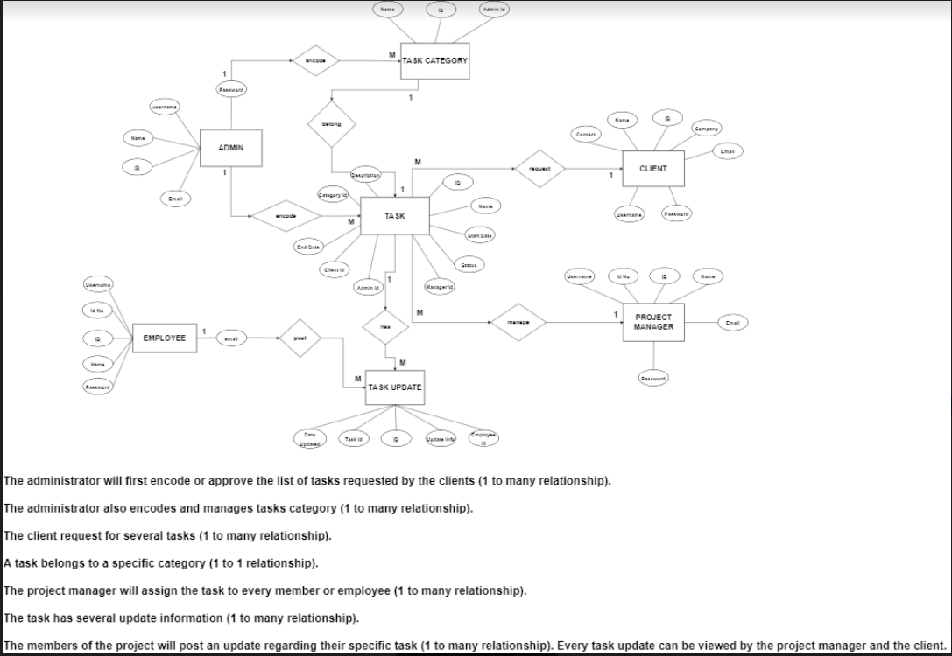

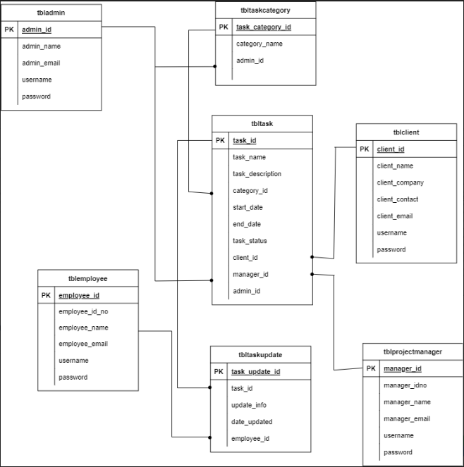

Description:

* Admin:

+ Primary key: admin_id → for linking to task table attached with task_id and task category attached with task_category_id in supervising two of them.

+ Other attributes: admin_name, admin_email, username, password

* Employee:
* Primary key: employee_id → for linking to task update table in maneuvering that update corresponding to the specified employee.
* Other attributes: employee_name, employee_mail, username, password, employee_id_no.
* Project manager:
* Primary key: manager_id → for linking to task table in managing that task corresponding to the specified manager.
* Other attributes: manager_name, manager_email, username, password, manager_id_no.
* Client:
* Primary Key: client_id → for linking to task table in interacting with that task corresponding to the specified clients.
* Other attributes: client_name, client_contact, client_email, client_ company, username, password, client_id_no.
* Task category:
* Primary key: taskcategory_id → for linking to task table corresponding to the specified category.
* Other attributes: category_name, admin_id(linked by the specified admin in supervising the category).
* Task update:
* Primary key: task_update_id → for linking to task table corresponding to the specified update.
* Other attributes: update_info, data_updated, task_id(linked by task table for specified task to be updated), employee_id(linked by the specified employee doing the update).
* Task:
* Primary key: task_id → for linking to task update table corresponding to the specified task to be updated.
* Other attributes: task_name, task_description, task_status, start_date, end_date, category_id(linked task category table for specified category), client_id(linked by client table for specified one interacting with that task), manager_id(linked by the project manager table for specified one managing that task), admin_id(linked by the admin table for specified one supervising that task).

**—------------------------------------------------------------------**

## CHAPTER 4: IMPLEMENT JAVA CODE & SQL QUERY

* ***Code Java:***
* Our main folder :

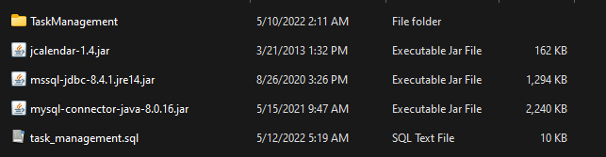

* Connection to mySQL: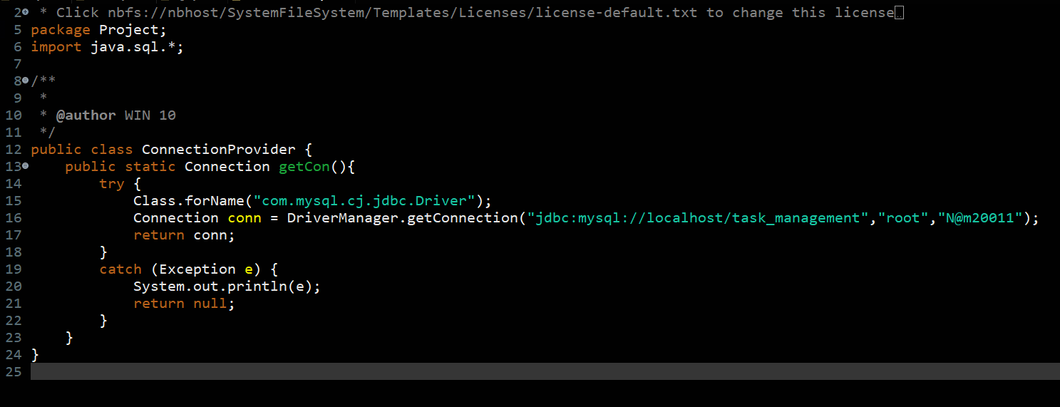
* Main file:

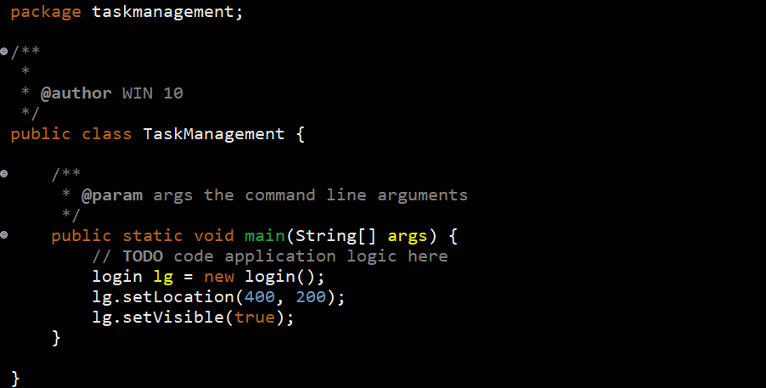

**Other folders:**

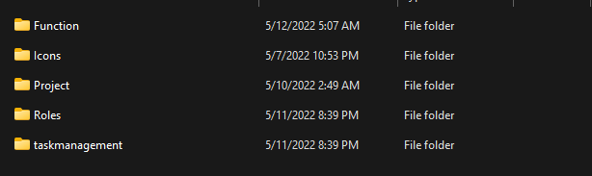

Function Files:

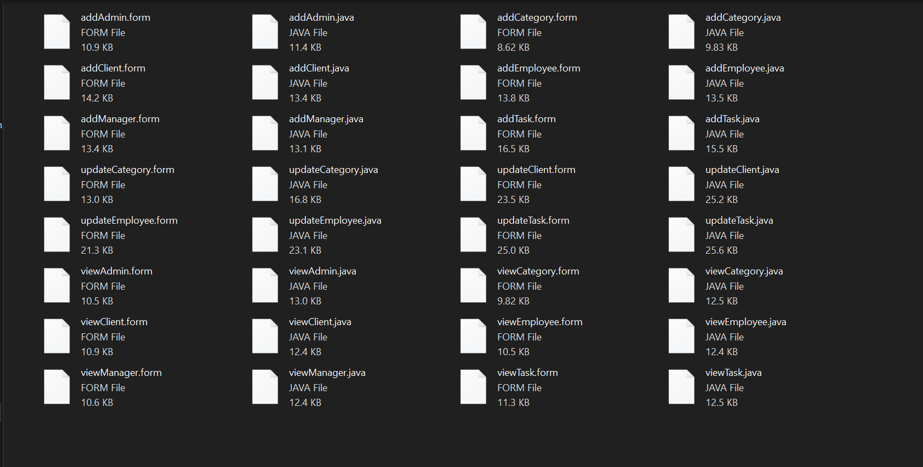

Icons: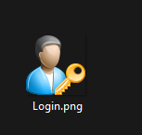

Roles:

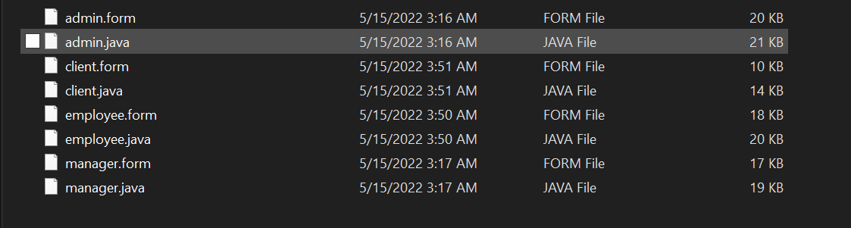

* **MySQL Query:**

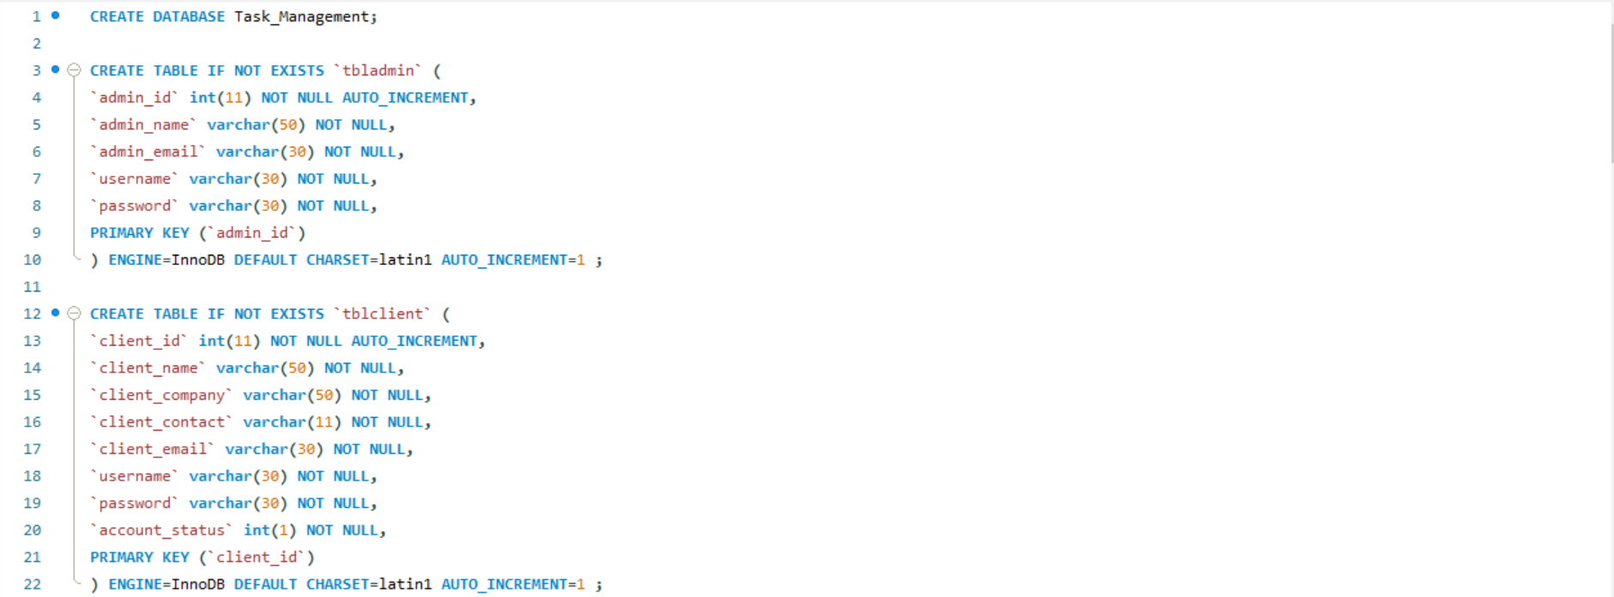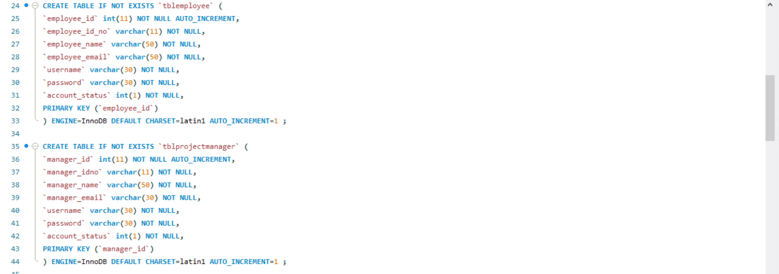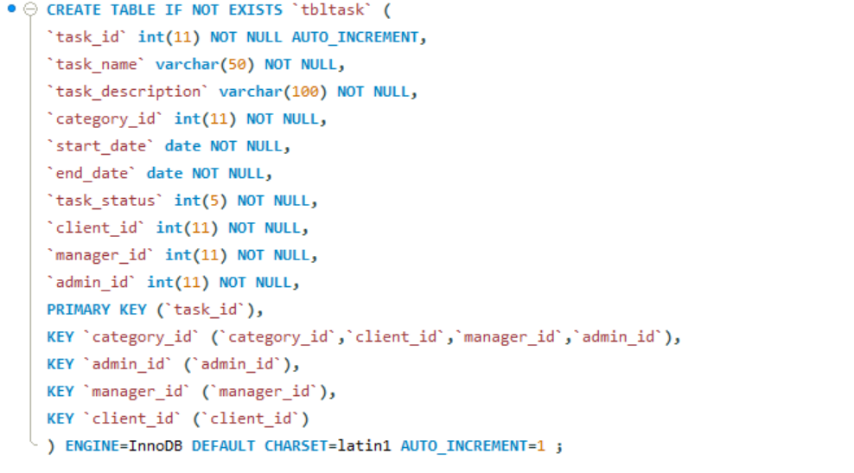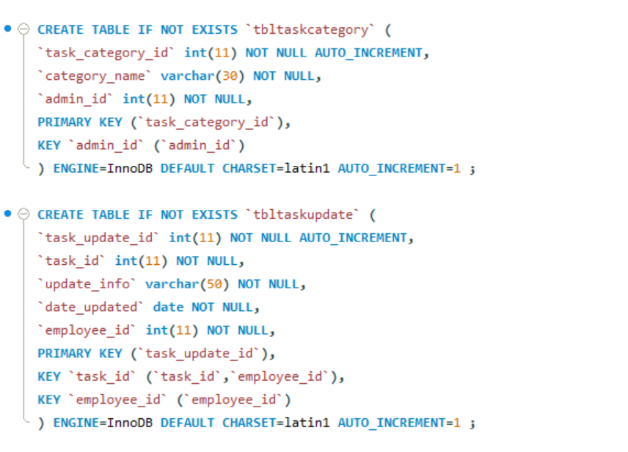

***Constraints for dumped tables:***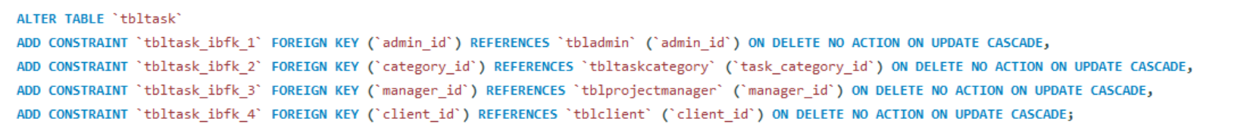

***Constraints for table `tbltaskcategory`:***

***Constraints for table `tbltaskupdate`:***

**=> OUR SOURCE CODE AND SQL QUERY WILL BE COMPRESS TO ZIP FILE WITH THIS REPORT.**

**—------------------------------------------------------------------**

## CHAPTER 5: *HARDWARE & SOFTWARE REQUIREMENTS:*

* ***HARDWARE REQUIREMENTS:***

**=> The hard requirements for our application can be changed during the development of our application.**

| **Category** | **Minimum** | **Maximum** |  |
| --- | --- | --- | --- |
|  | | **Windows** | **MAC OS X** |
| **PROCESSOR** | **Intel P-IV system** | **Intel Core i3 and above (such as Intel Core i5, or Intel Core i7) OR AMD FX 4100 and above, or A6 and above** | |
| **HARD DISK:** | **40GB** | **1 TB** | **128GB+Solid State Disk(SSD) with at least 50 GB of free disk space** |
| **RAM:** | **2GB** | **64GB** | |
| **PROCESSOR SPEED:** | **833MHz** | **4500MHz** | |
| **Wired Networking:** | **Ethernet LAN Port or USB** | **Ethernet LAN Port or USB Ethernet Adapter/Dongle** | |
| **To use the CBS wired network connection on your ultra-light or MacBook Air PC, you will need to purchase a USB-to-Ethernet Adapter.** | |
| **Wireless Networking** | **802.11g** | **802.11ax** | |

* ***SOFTWARE REQUIREMENTS:***

| **Category** | **Minimum** | **Maximum** |
| --- | --- | --- |
| **OPERATING SYSTEM:** | **Windows 2000 Professional** | **Windows 10 and above** |
| **ENVIRONMENT:** | **Java 8** | **Java 17** |
| **.NET FRAMEWORK:** | **Version 1.0** | **Version 4.7.2** |
| **LANGUAGE:** | **Java** |  |
| **BACKEND:** | **MYSQL COMMUNITY** |  |

**—------------------------------------------------------------------**

## CHAPTER 6: APPLICATION DEMO

**After open the application, it will pop-up a window like a figure below.**

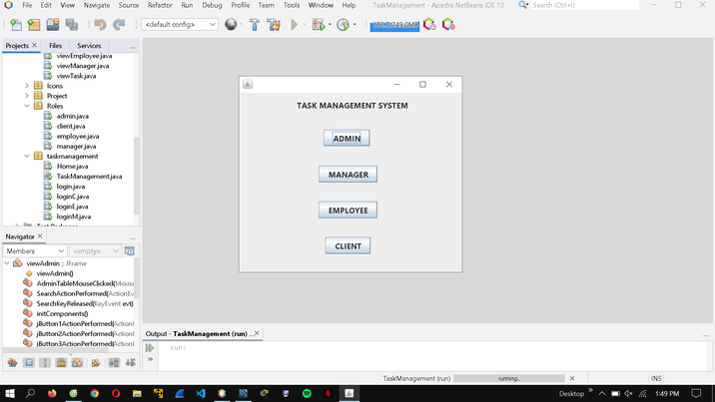

***The login page will appear after choosing a role***

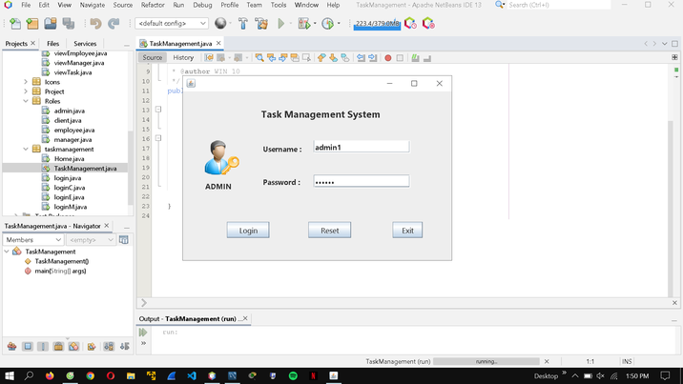

***After having logged in, popping up the types of users menu,***

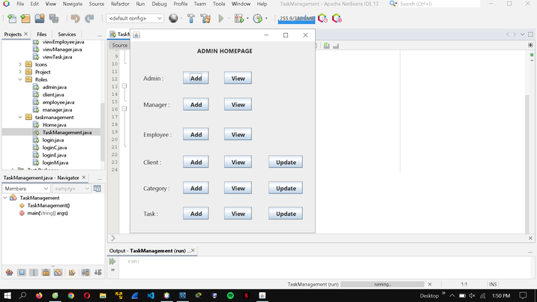

***And here come the admin controllers with specific actions***

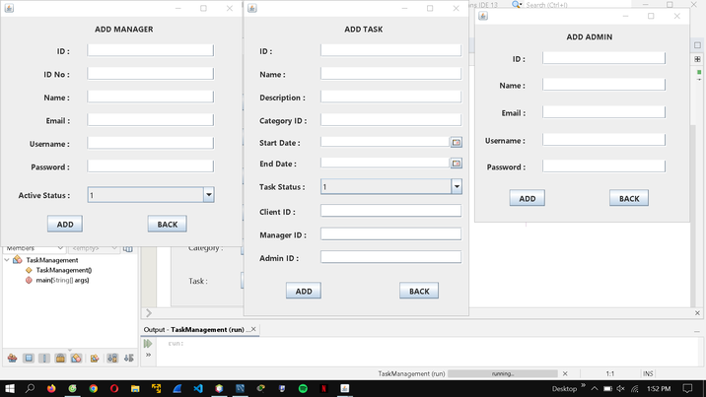

***The adding procedures maneuvered by the admins for managers, tasks, and admins themselves***

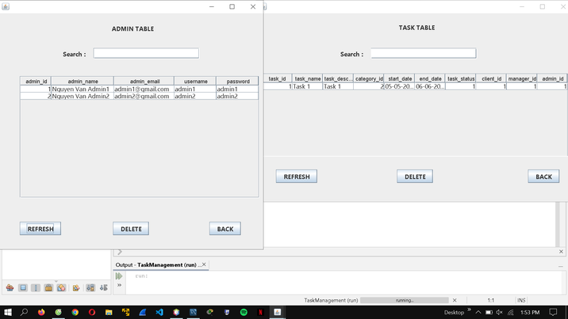

***Next, the views show up for searching and managing the info in the database***

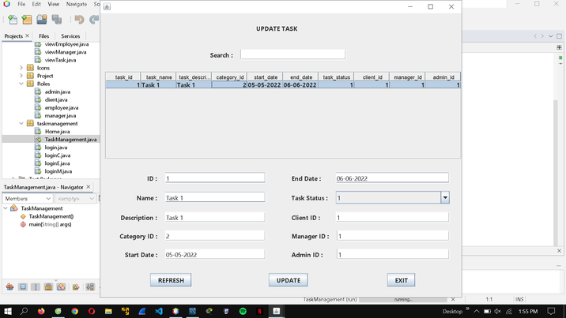

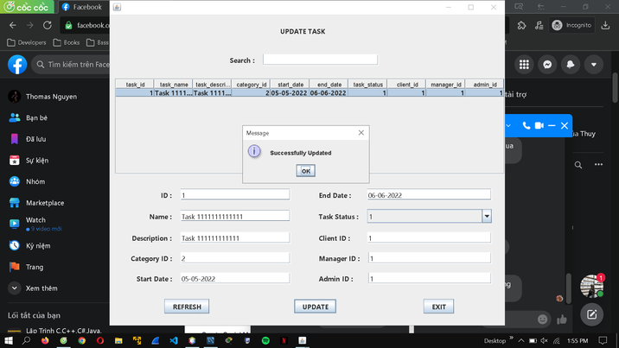

***The update task menu for the admin to put on some new tasks’ info which once being updated, the successful notification appears.***

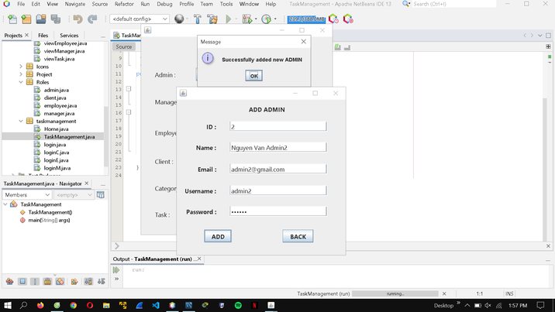

***Also, the menu for the admins themselves updating their info too***

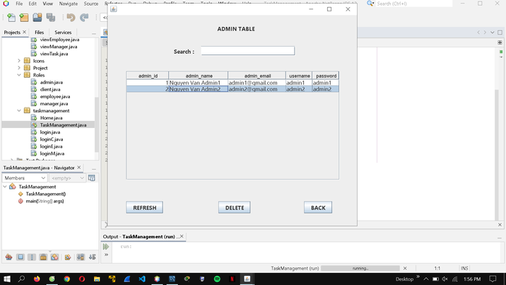

***Once the new admin’s info is updated, appearing on the general admin table***

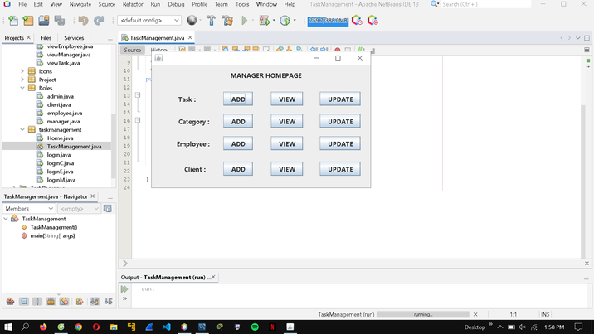

***The manager themselves also their homepage controller which has the same as but fewer entities than the admins (full controllers)***

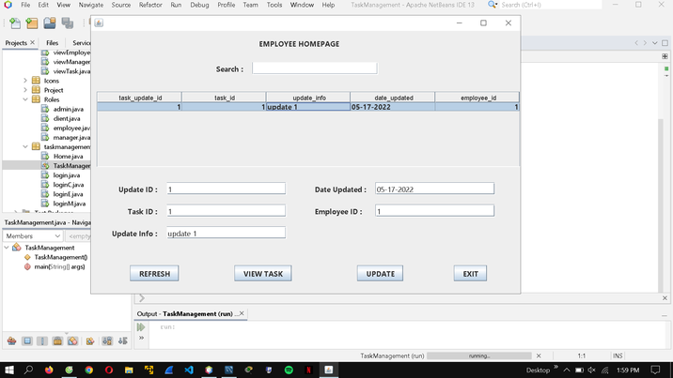

***This homepage is for employees working on each task to view and update their tasks***

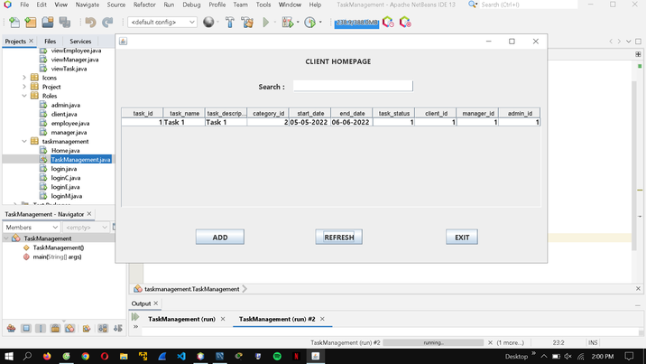

***Finally, the clients have their homepage to view and add their info***

**—------------------------------------------------------------------**

## CHAPTER 7: CONCLUSION

* **Advantage:**
* **Significantly strengthened data exchange:** Our system facilitates the formation of an environment in which end users have better exposure to even more better-managed data. Plus, data may be exchanged across authorized database users. Each user has individual access privileges to the database. The database is readily available to the admin. He has the power to add users to the database. End users can immediately respond to changes in their environment with this kind of access.
* **Easy data retrieval:** A user can retrieve data either from a particular table or from any number of related tables within the database. This enables the user to view the information in an almost unlimited number of ways.
* **Built-in multilevel integrity:** Data integrity is built into the database at the field level to ensure the accuracy of the data; at the table, level to ensure that records are not duplicated and to detect missing primary key values; at the relationship level to ensure that the relationship between a pair of tables is valid; and at the business, level to ensure that the data is accurate in terms of the business itself.
* **Better decision-making:** Better-organized data and more straightforward and quicker access to information equip us with higher-quality data that facilitates in making of more intelligent decisions. The efficiency of the original data largely determines the usefulness of the data generated. Data quality pertains to a comprehensive view of guaranteeing data correctness, authenticity, and dependability. While our system can not help ensure data quality, it provides a foundation for data quality activities. End-user productivity has been boosted.
* **Disadvantage:**
* **Data Quality:** Suitable and sufficient controls are required to control the users who are updating the data and control the data quality. Direct access to data by various users leads to massive opportunities for users to damage the data. So if no suitable controls are available then it may be possible that data is compromised.
* **Maintenance:** Apart from management, a database management system must be maintained regularly so that it can make the system current. Only by staying current, the users can acquire the maximum efficiency of a database system. However, that is not a simple task since maintenance involves a significant amount of expenses.
* **Hardware and software expenditures:** We require a high-speed CPU and a huge working memory to perform our system, which necessarily involves the acquisition of pretty expensive hardware. The investment in maintaining the hardware, software, and employees required to run and operate a database system may be particularly significant. When database systems are installed, issues such as training, licensing, and regulatory compliance are sometimes underestimated.
* **Lessons Learned:**
* Move quickly through SQL basics and several advanced features.
* Use SQL data statements to generate, manipulate, and retrieve data.
* Create database objects, such as tables, indexes, and constraints with SQL schema statements.
* Know how datasets interact with queries; understand the importance of subqueries.
* Convert and manipulate data with SQL’s built-in functions and use conditional logic in data statements.
* **References:**

For connection between java code and MySQL Query:

[**https://www.marcobehler.com/guides/java-databases**](https://www.marcobehler.com/guides/java-databases)

For UX/UI design and function button:

[**https://www.javatpoint.com/java-swing**](https://www.javatpoint.com/java-swing)

**THIS IS THE END OF REPORT, OUR GROUP WANT TO SAY THANK YOU FOR MRS NGUYỄN THỊ THÚY LOAN FOR TEACHING AND SUPPORTING US DURING THIS LECTURER.**

**Thank you for your reading**

**—------------------------------------------------------------------**